Kings & Quarry House Surgery Activity Data For March 2024

  Calls Handled by the Surgery:  3500 |   Calls Answered Within Two Minutes:  2787 |   Number of calls  Abandoned:  255 |   Text Messages Sent/received:  468
  Appointments Available:  1856 |   Appointments Seen:  1778 |   Appointments Missed:  163 |   Total Digital requests submitted to the Surgery:  438
    Administrative Communications Issued (letters/emails): 820 | 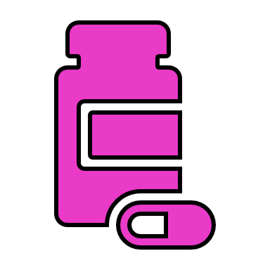  Items Issued Via Prescriptions:  3349 |   Medical Sick Notes Issued:  128 |   Referrals Made:  186

